CIn Lynn Davis, Senior Pastor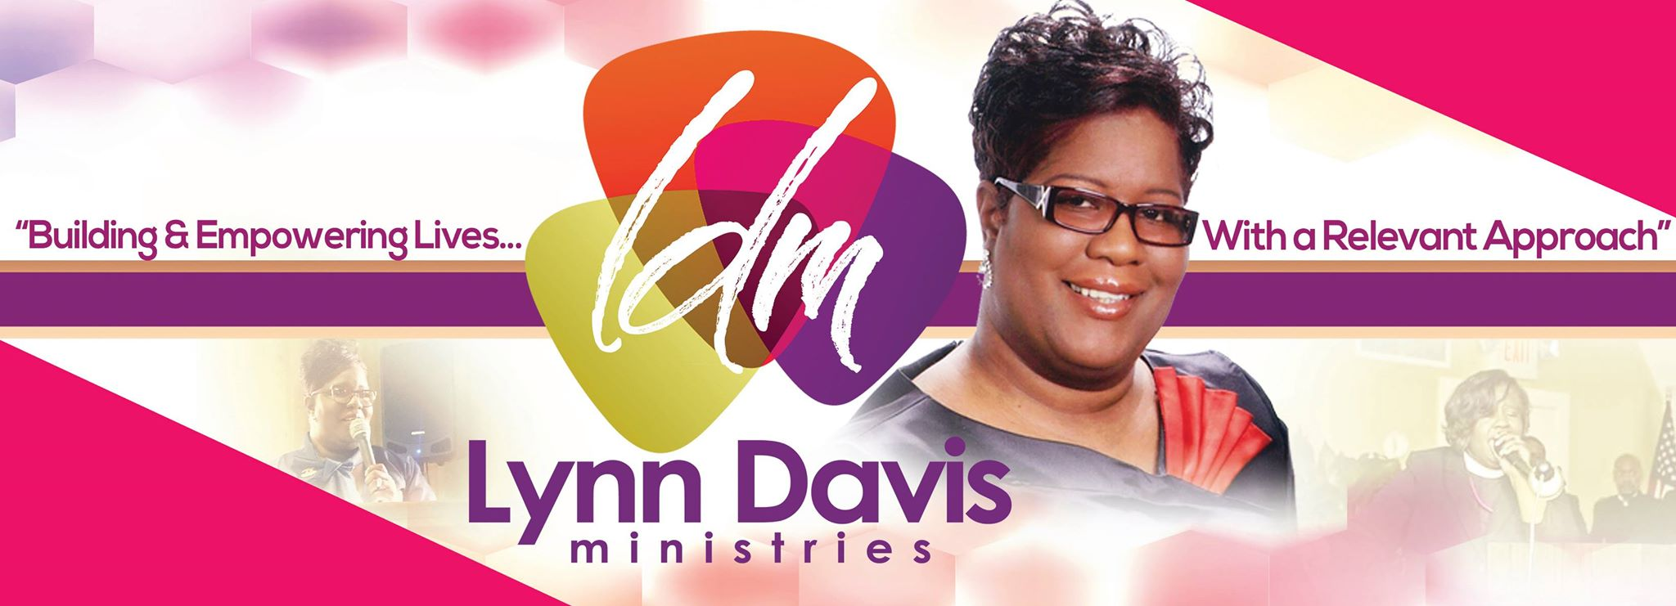

PROFILE: REVEREND LINDA DAVIS “aka Pastor Lynn”

Reverend Linda Davis affectionately known as “Pastor Lynn” founded Linda Lewis Ministries in '1992 and End Time Harvest Outreach Evangelistic Crusade Ministry in '2007. She is a native of Amityville, NY, where she accepted the Lord Jesus Christ and the Baptism of the Holy Ghost at the age of 16 at Faith Temple COGIC. She was joined in Holy Matrimony to the Minister Darrel S. Davis in October of 2014. She is a Spiritual daughter of the Bishop Milton E. Rochford of All Saints (King’s Temple) COGIC for over 25yrs, where she served as Chairlady of the Youth Dept., formally received her call to Evangelism and the birthing of her Chaplaincy Ministry. She served the Nat’l Dept of Evangelism of COGIC for 7yrs as the Regional Director/Elect Lady of “Northeast” Region #10, which consisted of 8 States & 26 Jurisdictions Pastor Lynn Davis served in many capacities in the church, such as New Converts Care Coordinator & Pastoral Counselor and the Piggy-Back Prison Program Coordinator, in transition to the Pastorate. She was a Broadcast Announcer since 1990 beginning with WTHE of Mineola, NY, WMCA/WWDJ of Rutherford, NJ, WGBB of Babylon, NY to WEHA of Atlantic City, NJ where she served as Program Director 2012-2013 the Year they’ve received the highest honor in Small Radio Broadcast, the “Stellar Award.” The Lord gave her to establish her own Radio Show called “15 Minutes of Faith w/ Pastor Linda on WEHA in 2012. She has a wealth of experience as an Evangelist, Pastoral Counselor and in Chaplaincy as a Pastoral Caregiver. This woman of God has birthed the Empowerment & Impartation Conference in 2007 where she's received speakers such as Bishop Jackie McCullough, Co-Pastor Shirley Graham and others.

In July of 2010, Pastor Lynn became Founder/Senior Pastor of the Harvest Church, and a year later went under the covering of the Bishop Robert J. Rochford Sr. & the late Pastor Lois E. Rochford, of Dunamis Covenant Connection since 2011, where The Harvest Church now known as The Harvest Chapel was one of the founding churches. Pastor L. Davis has been a Parish Pastor for 10yrs and a Institutional Pastor for over 25yrs. In 2012, she founded the Grace I. Ross-Lewis Resource Center, which was named after her sister, the late Evang. Grace Irene Ross, this center serves the community in many capacities. Every year Pastor Lynn and her husband, through The Harvest Chapel/ Grace I. Ross Lewis Resource Center partnered with Bishop David G. Evans & Bethany Baptist every Thanksgiving to give away over 100 turkeys & care packages. The Harvest Chapel has partnered with the “Unforgotten Haven” to feed and clothe families, year round. Pastor Lynn and the Harvest Chapel/G.I.R.L. Resource Center, presents every year for Christmas “Adopt-A-Family,” to provide Toys and Bicycles for under priviledged families, in partnership with “The Camden Mission,” “The Unforgotten Haven” and “The Mayor’s Office of Gloucester Township, NJ.” The Back-To-School Back-Pack Giveaway is one of her favorite community efforts, because pesons of all nationalities come on a common ground to sit and eat together and fellowship. Pastor is a member of the Atlantic City & Vicinity Fellowship of Churches, the Gloucester Township Ministerium, Pastors & Ministers Conference of Camden County & Vicinity and a Member of “Conversation of Your Life” Task Force (the Mayors of NJ Wellness Program, through the New Jersey Health Care Quality Institute, Princeton, NJ) & the Office of Homeland Security and Protection Interfaith Council/Task Force. Most of all, Pastor Lynn is a Woman of God that desires to see the masses of people across this world, in need of Reconciliation & Healing, to experience the Compassionate Love of Jesus Christ and receive Him in their hearts as their Lord and Savior.

Chaplain/ Pastoral Counselor
Chaplain Davis began her Journey at the age of 27yrs old and became a Community Para-Chaplain in 1993 and by 2002 received her accomplishments as Administrative Chaplain and Professional Chaplain. Pastor Lynn is an Ordained/Ecclesiatically Endorsed National Institutional Chaplain in Healthcare, Corrections, Federal Bureau Department of Justice, Police, Veterans Administration & the Red Cross since August '2003. She was ordained under special circumstances by the late Bishop G.E. Patterson, under Bishop John I. Little the Commissioner of Military & Institutional Chaplains Division of the Church of God in Christ, Inc. She currently serves as the 1st African American and Female Chaplain of the Gloucester Township Police Department since 2017 and New Jersey Regional Red Cross Chaplain since 2019. She served as a Protestant Staff Chaplain & Program Coordinator at Riker's Island, Para-Chaplain at Arthur Kill Correctional Facility, Administrative & Community Chaplain for the Citi-Back Revitalization Program, Adjunct Teacher and Special Asst. to the Chancellor of the All Saints Chaplaincy Academy in both New York & New Jersey. She is a Certified Pastoral Counselor/Clinical Chaplain, Certified HIV/AIDS Counselor, Alcohol/Drug Counselor where her specialty is the Mentally Ill & Chemically Addicted (MICA). Chaplain Davis served as a Hospice Chaplain for 10yrs. in the Ocean/Atlantic County Area of Southern New Jersey, and Volunteer Veterans Chaplain at Veterans Haven-South, Winslow, NJ under the leadership of Col. Walter Nall (a 95 Bed Transitional House for Veterans Only)for 7yrs. Under the administration of Mayor Micheal Bloomberg, she served as a Chaplain with Rev. Susan “SueJay” Johnson and the Women of Faith, as a taskforce and spiritual consultants to the Speaker of the House in Town Hall, New York City, NY. She has served under National Director/Endorser, Bishop John I. Little, Bishop Morgan, Arch-Bishop J. Delano Ellis and currently Chaplain Carlos Bell. She served under the Presiding Bishop G.E. Patterson and currently under the Presiding Bishop Charles E. Blake, Sr. In October '2016, Chaplain Linda was appointed the National Director/Endorsing Agent of Chaplaincy and in October '2018 at the 7th Holy Convocation she was Consecrated Overseer of National Chaplaincy, by the Chief Prelate of Dunamis Covenant Connection. She’s resolved all responsibilities with DCC to continue her education in Seminary in ‘2020. However, she and her husband, the Rev. Darrel S. Davis Sr. are Pastors of The Harvest Chapel a Non-Denominational/Christian Church, “A Place of Compassion, Reconciliation and Healing.”

Worship Leader
As Worship Leader Pastor Lynn’s musical career has allowed her to record with Pastor Donnie McClurkin & N.Y. Restoration Choir, Pastor Lynn has been privileged to travel and sing with ministers of the gospel such as Pastor Timothy Wright and sing with Dr. Mattie Moss Clark & the Michigan State Community Choir, & others. She's attended the Mattie Moss Clark Conservatory of Music in the mid 80’s where she served as a choir member at the Greater Mitchell COGIC, in Detroit MI under the leadership of the Supt. John H. Sheard. Because of her faithfulness, her Pastor, Supt. Sheard, gave her permission to fill in for Elbernita “Twinkie” Clark as musician for Elder Elbert Clark’s Sunday Night Broadcast Service at Berea Church of God in Christ. She remembers the stipulations clearly to this day. And they were, “as long as you make it back to your Sunday Evening Service, I’ll release you to do it.” Supt. Sheard was more concerned about our faithfulness to God as young adults and he knew that we needed to be accountable. From 2013-2015 Pastor Lynn was asked by Dr. Dorinda Clark-Cole, to be the Regional Coordinator for the “East Coast Singers, Musicians & Arts Conference “SMAC.” It was purposefully designed to provide opportunities for singers & musicians and to be a blessing in helping them to further their ministry of music and arts.

​Teacher/Preacher
Pastor Lynn’s faithfulness to God has afforded her the opportunity to minister in places like Canada, Bahamas, the Northeast Region & parts of the West Coast. She is a Preacher/Teacher impacting the Kingdom of God, "One Soul At A Time" and “Building & Empowering Lives With A Relevant Approach.” She's the youngest of 13, and a 2nd generation woman minister. Pastor Lynn Davis was licensed National Evangelist in the Church of God in Christ, May '2000 under President Richard "Mr. Clean" White. She served as Chaplain on the Executive Board of the Jurisdictional Women's Dept. of the NJ New Garden State Jurisdiction under the Bishop William T. Calhoon & Evangelist Dept. Chairlady. Now, she is a member of “Those Preaching Women” where she’s being mentored by the Bishop Corletta J. Vaughn. Also, she and her husband attend Seminary on Sundays inaugural Semesters of 2020-2021, with the Chancellor, the Bishop, Dr. John Gunn. Pastor Lynn Davis a graduate of Saints Academy in Lexington, Mississippi, a Bachelor Degree in Religious Education from M.K.W. Religious Training Institute (Affiliate of C.H. Mason Bible College), a Masters of Arts in Theology from Progressive Universal Bible College of Sacramento, CA and Molloy College of Rockville Center, NY where she obtains an Associate of Arts Degree w/ a concentration in Theology. As of January 2020, she’s currently a graduate student at Virginia Union University School at the Samuel DeWitt Proctor School of Theology where she’s pursuing her Master of Divinity Degree. She’s been the recipient of the Eagle of Excellence Awards in 2016 where she’s received four Honors and the City of Hope Bible College & Seminary- Atlantic City, NJ, Excellence Awards Honors in 2015 where she’s received an Honorary Doctorate Degree in Philosophy for her extensive years of service in Chaplaincy and in Broadcasting.

